**Dot Frequency Graphs or Dot Plots**

Dot Plots are a great way to give a quick picture of our data. It also allows us to identify:

1. The spread of the data
2. The mode of the data.

**Drawing a Dot Plot**

**Example**

The ages of an audience at a concert were recorded as follows:

12, 14, 13, 11, 10, 16, 17, 13, 12, 10, 10, 14, 15, 15, 12, 15, 17, 15

To draw a dot plot for this information you need to

1. Determine the highest and lowest values
2. Draw a number line that starts at the lowest and finishes at the highest.
3. Now place a dot above the 12 for the first person and then a dot above the 14 for the second student and so on.
4. If you get to a value that already has a dot then put another dot above this one.
5. The dots need to be evenly spaced to give an accurate picture.

Modal Score simply means what was the most common value or most frequently occurring value.

The modal age in the above example is __________

**Worksheet on Dot Plots**

**Question One:**

The values below give the resting pulse rate of 20 students.

56, 60, 65, 70, 64, 66, 72, 80, 64, 64, 60, 58, 69, 71, 68, 78, 64, 65, 66, 70

a) What is the highest pulse rate

b) What is the lowest pulse rate

c) Draw a dot plot for the information

d) What is the modal pulse rate?

**Question Two:**

|  |  |
| --- | --- |
| Hours of Homework | Frequency |
| 1 | 3 |
| 2 | 4 |
| 3 | 7 |
| 4 | 7 |
| 5 | 5 |
| 6 | 3 |
| 7 | 2 |

The number of hours that year 8 students did on homework in one week was recorded down in the frequency table below.

Draw a Dot Plot for the information above.

What was the modal number of hours,

**Describing the spread of Dot plots**

We can use the overall picture of the dot plot to give a description of the data. The following is a summary of some descriptions of dot plots based on the spread of the dots.

Symetrical Skewed Right

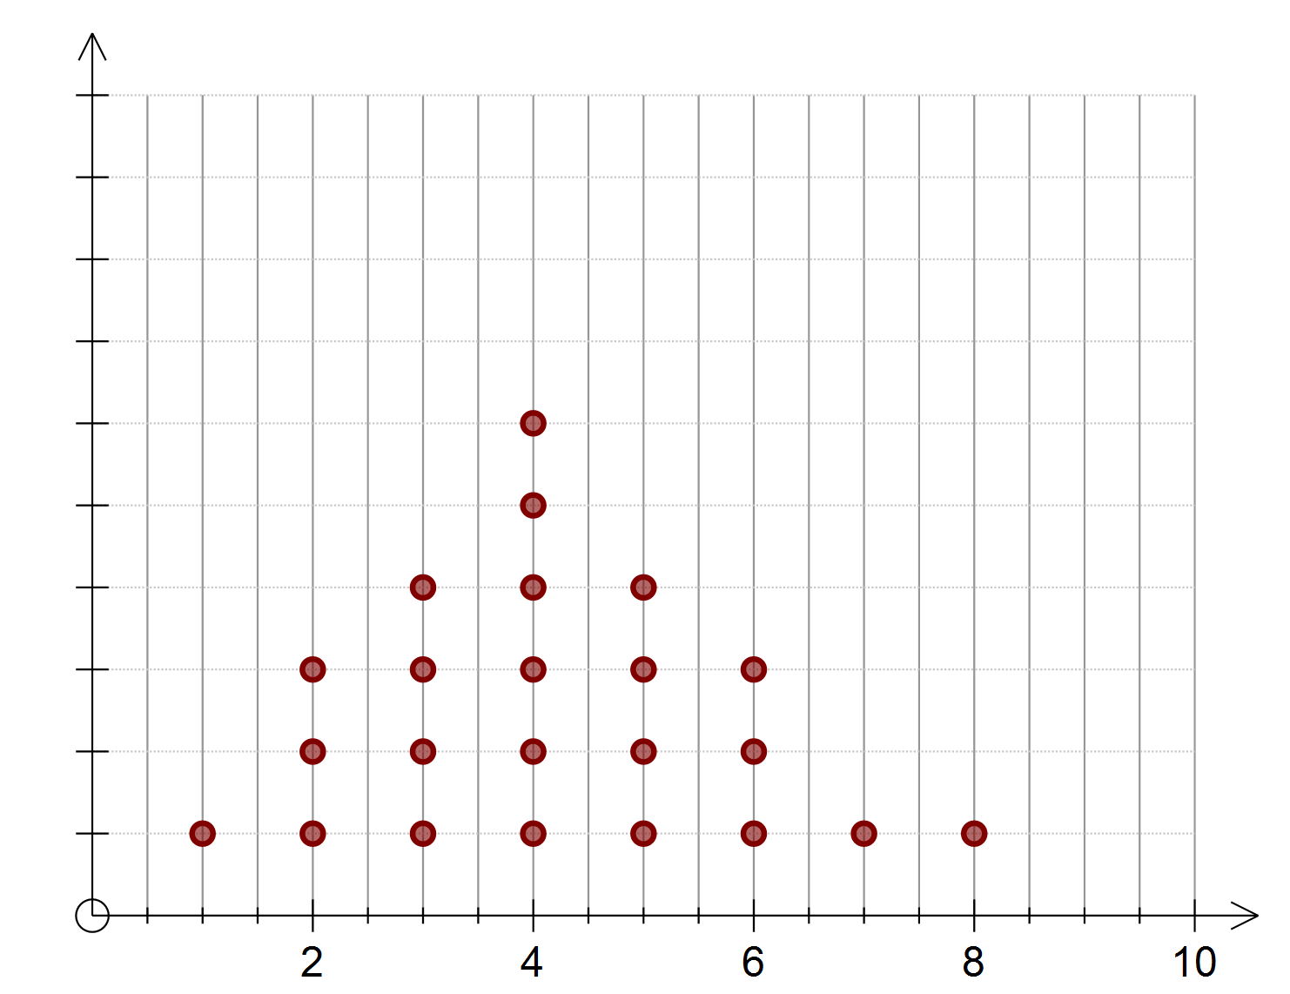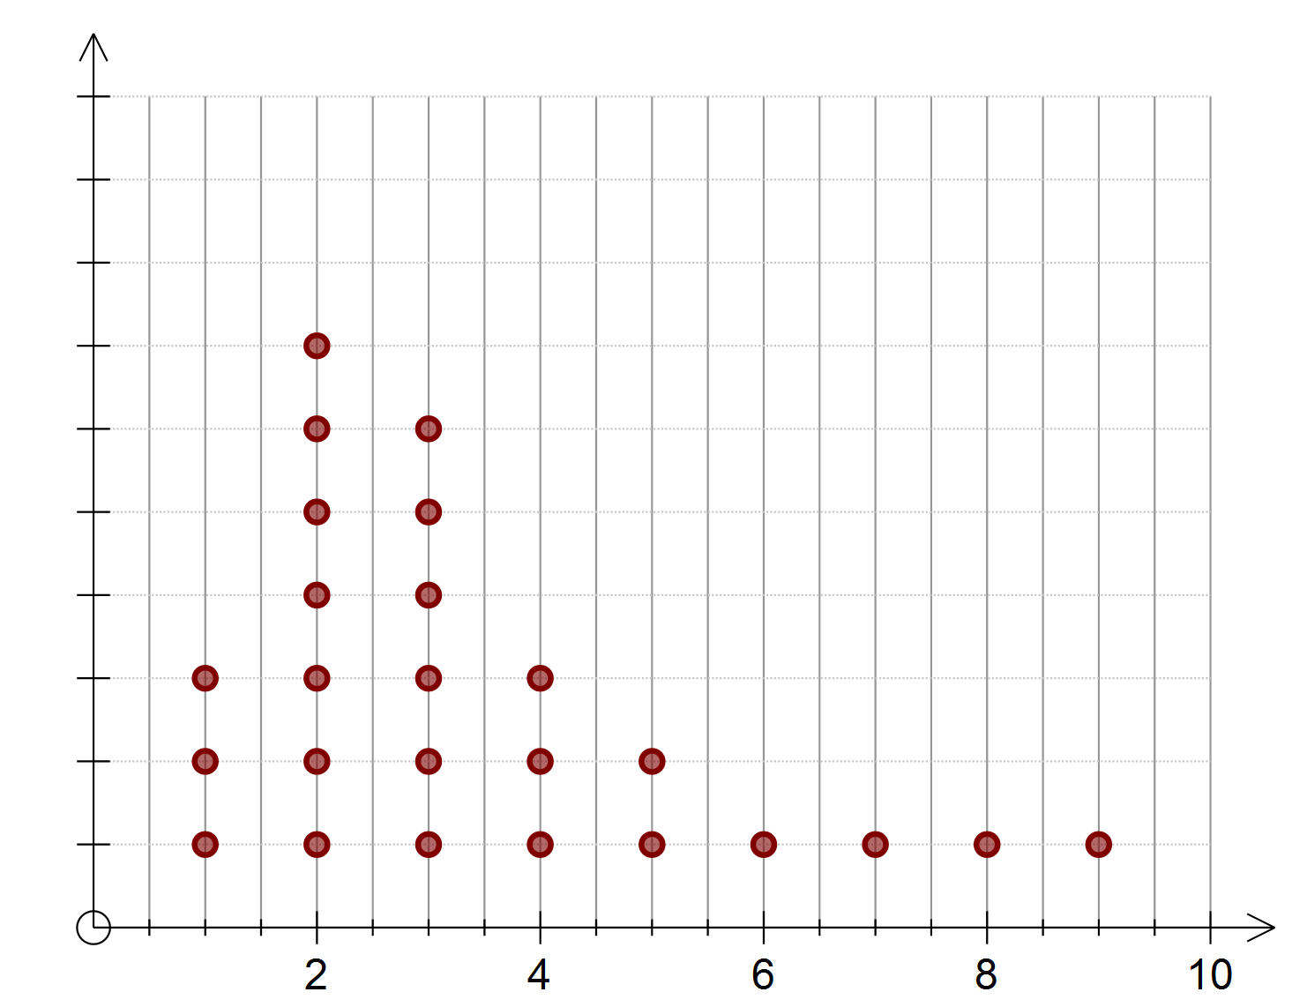

Skewed Left Bi modal

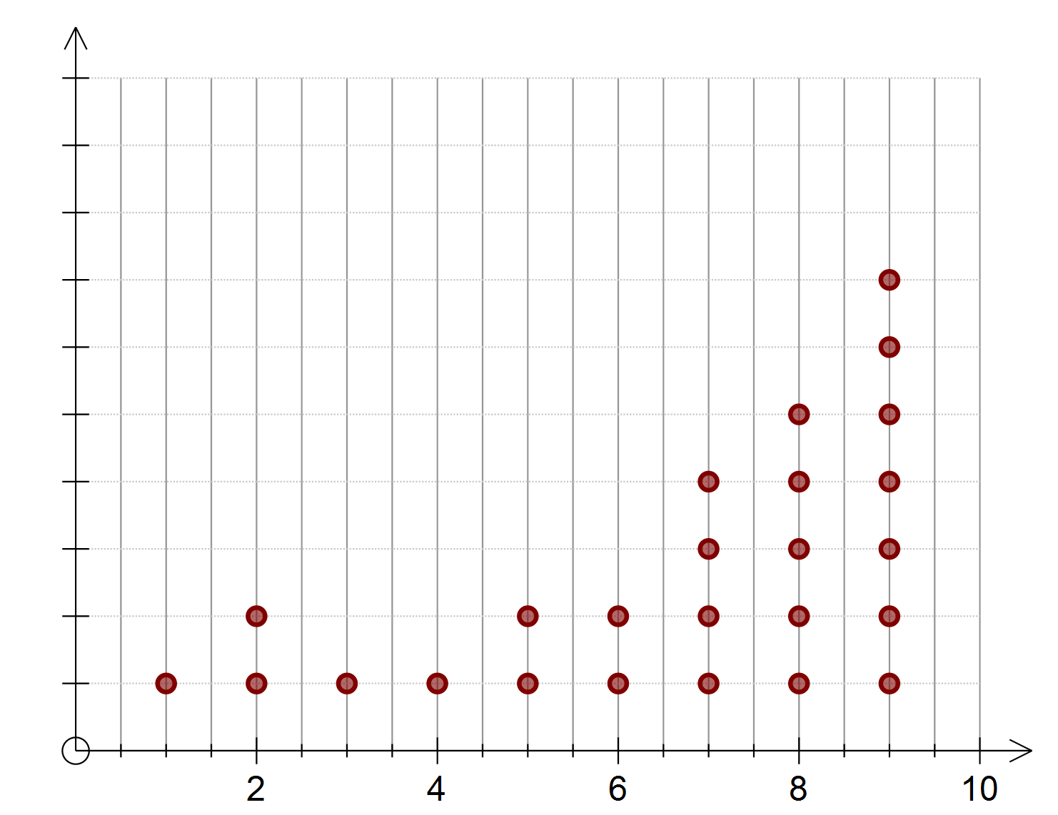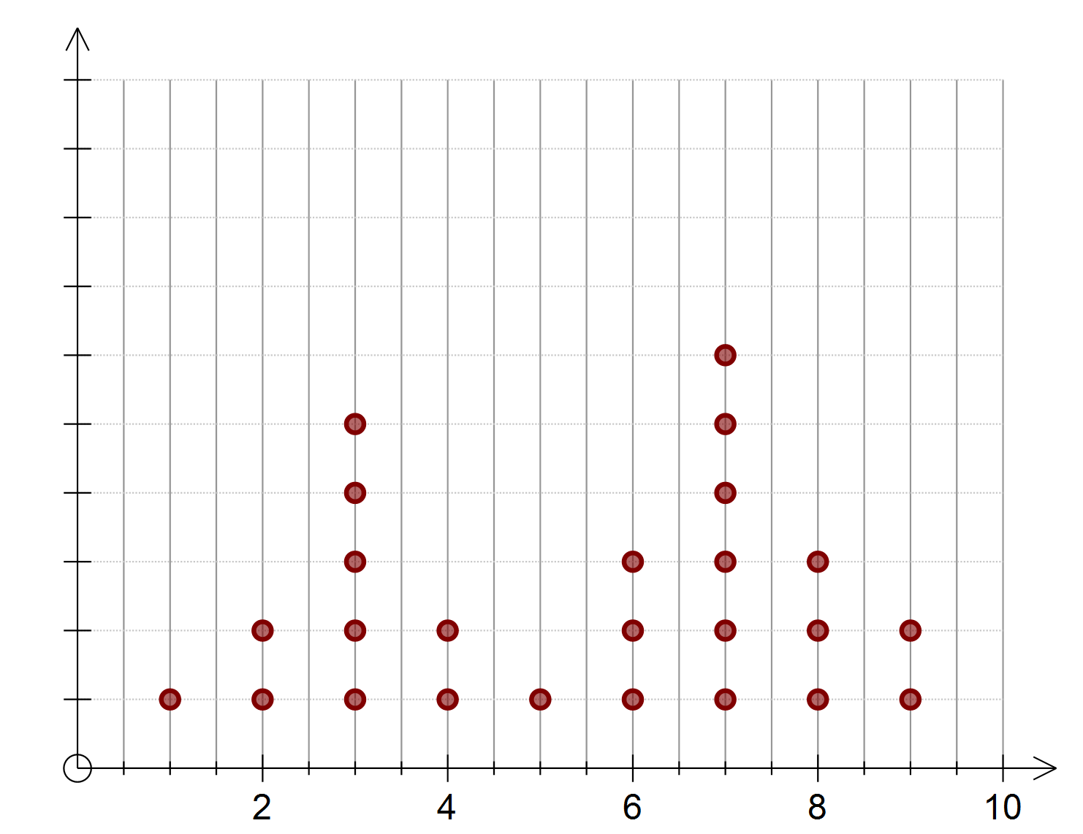

Uniform

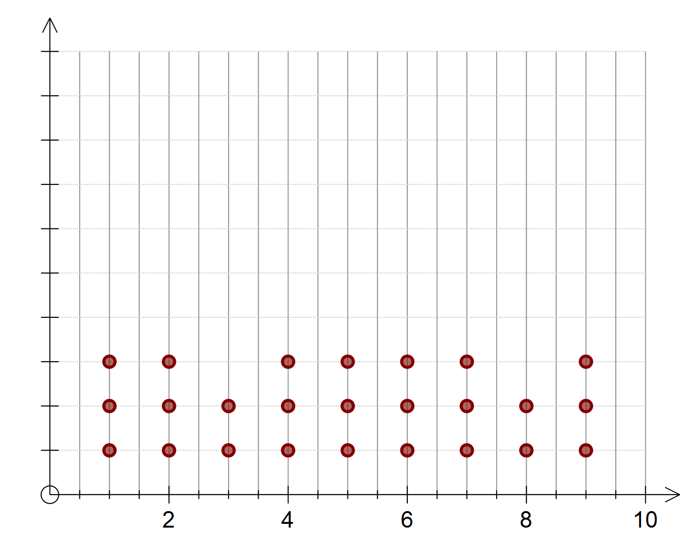

Construct a Dot Frequency Graph from the data below



Construct a Dot Frequency Graph from the data below

