CHAPTER 4 TEST ON LESSONS 4.1-4.6

1

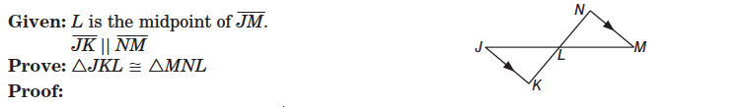



|  |  |
| --- | --- |
| Statements | Reasons |
| 1. | 1. |
| 2. | 2. |
| 3. | 3. |
| 4. | 4. |
| 5. | 5. |

2

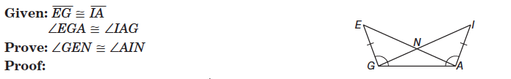

|  |  |
| --- | --- |
| Statements | Reasons |
| 1. | 1. |
| 2. | 2. |
| 3. | 3. |
| 4. | 4. |

3

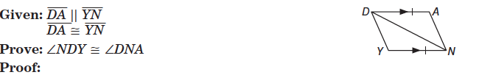

|  |  |
| --- | --- |
| Statements | Reasons |
| 1.Macintosh HD:Users:tracypullo:Desktop:Screen Shot 2015-11-02 at 4.38.18 PM.png | 1. Given |
| 2. | 2. |
| 3. | 3. |
| 4. | 4. |
| 5. | 5. |

4

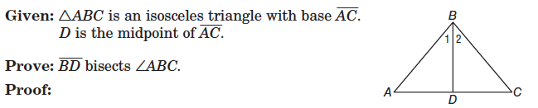

|  |  |
| --- | --- |
| Statements | Reasons |
| 1.Macintosh HD:Users:tracypullo:Desktop:Screen Shot 2015-11-02 at 4.29.16 PM.png | 1. Given |
| 2. <A congruent <C | 2.Def of isosceles |
| 3. | 3.def of isosceles |
| 4. | 4.Def of MP |
| 5. Triangle ABD congruent to Triangle CBD | 5. |
| 6. | 6.CPCTC |
| 7. BD bisects < ABC | Converse of Angle Bisector |

5.

Macintosh HD:Users:tracypullo:Desktop:Screen Shot 2015-10-30 at 6.39.50 PM.png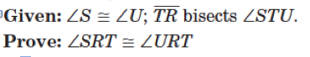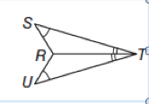

|  |  |
| --- | --- |
| Statements | Reasons |
| 1. | 1. |
| 2. | 2. |
| 3. | 3. |
| 4. | 4. |

6.

Macintosh HD:Users:tracypullo:Desktop:Screen Shot 2015-10-30 at 6.42.40 PM.png

AB=______________________________________________________________________________________________

BC=______________________________________________________________________________________________

AC=______________________________________________________________________________________________

Classify the triangle by its sides_____________________________________________________________________

7.

