1.3 REVIEW NOTES AND PRACTICE
The Midpoint of a segment is the point that divides the segment into two congruent segments.
The midpoint coordinate point can be found by using the following MIDPOINT FORMULA: 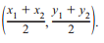

A SEGMENT BISECTOR is a point, ray, line segment, or plane that intersects the segment at its midpoint.

The DISTANCE FORMULA is used to find the length of a segment on the coordinate plan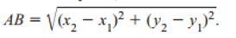

FIND THE MIDPOINT OF AB
FIND THE DISTANCE OF AB 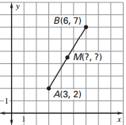

1.4 VOCABULARY
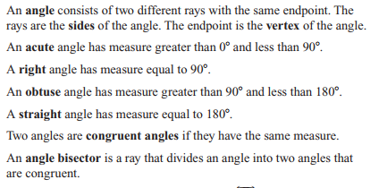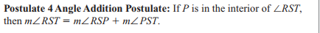
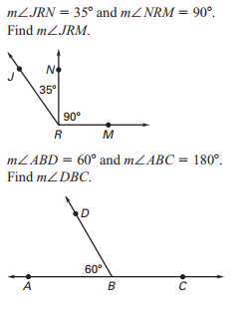
1.5 VOCABULARY
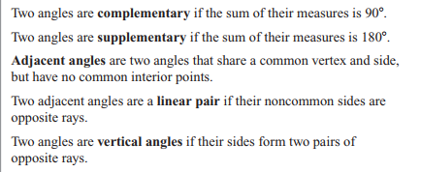
Examples from 1.5
