Similarity/Dilation Project

Mural artists use similarity to help them create their larger artwork. Muralists begin creating a mural by drawing a small picture with a grid of squares drawn over it. They then divide the surface on which the mural will be painted into a similar but larger grid of squares. Proceeding square by square, they draw the lines and shapes of the original drawing into the corresponding positions of the mural surface’s larger squares. Finally, they paint in the regions to complete the mural.

The design in the small grid of squares below left is similar to the design in the large grid of squares below right. The enlargement was made by matching points in the original drawing to the corresponding points in the larger grid.

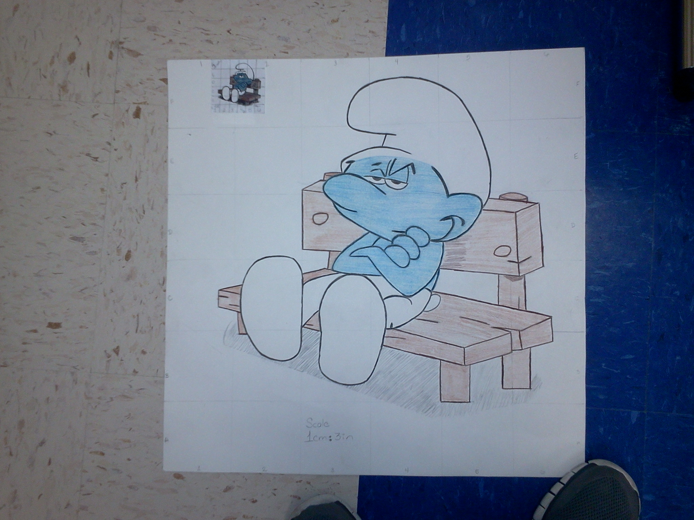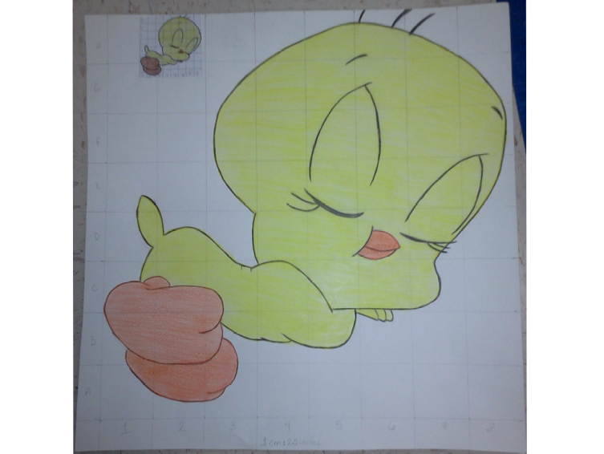

You will need the following materials to create your own mural.
- A cartoon, photograph, or small drawing to enlarge
- A poster board – I will provide
- Drawing tools such as a ruler, meter stick, markers, paint and colored pencils

Begin by constructing lightly in pencil a grid of squares on a copy of your cartoon, photograph, or drawing. The more squares you draw, the more accurately your mural will depict your original image. Again in pencil, divide the poster into a similar grid of larger squares. To create your mural, carefully draw lines and curves of the drawing in the small squares into their corresponding larger squares. Finally, color the appropriate regions.

Guidelines for Mural Project

- Minimum scale factor from the original grid to the enlarged grid should be 1cm: 2inches. You should make the enlarged grid as large as possible on your poster board.

- Put the following information on the back of the poster:
  - Your name and period
  - Measurement used to construct the original (small) grid
  - Measurement used to construct the enlarged grid
  - Scale factor for your project (should be at least 1cm: 2 inches)
  - Rubric on the following page

- The original picture should be securely taped or glued to the front of the poster where it does not conceal your finished product.

- The squares of BOTH the original grid and the enlarged grid should be numbered and/or lettered. You should have the same number of squares on each grid.

- Do NOT erase the grid on either the original or the completed mural. This is a major part of the project and should remain.

- Due date: The project is due on __FEBRUARY 28, 2014________
- If your project is late, you will lose 5 points for each day that it is late.

- I will use the following to grade your project:
_______ Original picture is approved
_______ Drawing meets the minimum size (scale factor is at least 1cm: 2in)
_______ Grid is visible on both the original and the enlarged picture
_______ Grid is numbered on both the original and the enlarged picture
_______ Original picture is secured to the front
_______ Required information is on the back (see #2 above)
_______ Accuracy in duplication of the original picture
_______ Project presentation (poster is flat, drawing is neat, coloring is bright, extra space cut off poster)

REQUIREMENTS FOR DILATION PROJECT

 | Poor  5 pts | Fair  10 pts | Good  15 pts | Excellent  20 pts | GRADE
PICTURE | Poor  Picture was not attached | Fair  Picture was attached, but no grid on it or headings(numbers or letters) picture very simple | Good  Picture was attached with grid and numbers but was simple | Excellent  Picture was very elaborate exp vase (was three dimensional, looked like still life)
SCALE MEASUREMENT | Poor  3 or more errors in  scale proportions | Fair  2 errors in scale proportions | Good  1 error in scale proportion | Excellent  no error in scale proportion | ___________
DILATION | Poor  3 or more errors in drawing, dilation did not look like the picture | Fair  2 errors on drawing or drawing was just an outline | Good  1 error in drawing, good drawing-drawing almost looked identical | Excellent  excellent - image looked identical except for size
Display | Poor  Unorganized, not creative | Fair  Lacked neatness | Good  Neat | Excellent  Very neat, detailed, colored | __________
ON TIME | Poor  THREE DAYS LATE | Fair  TWO DAYS LATE | Good  ONE DAY LATE | Excellent  ON TIME | ___________

