PULLO Notes on Quadratic Functions

A QUADRATIC EQUATION is a function that can be written in the form 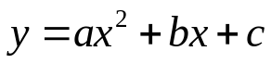 where a, b, and c are real numbers and a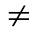0. Examples: 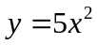 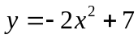 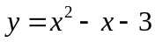

The graph of a quadratic function is a U-shaped curve called a PARABOLA. The maximum or minimum point is called the VERTEX.

Identify the vertex of each graph; identify whether it is a minimum or a maximum.
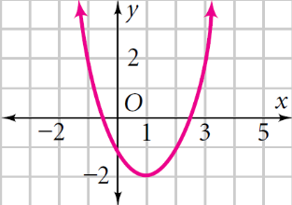
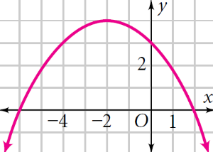
1.) 2.)

Vertex: ( , ) _________ Vertex: ( , ) _________

Key Features of a Parabola for 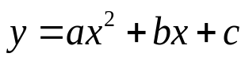
- Direction of Opening: When 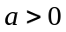, the parabola opens UP
When 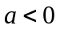, the parabola opens DOWN
- Width: When 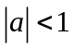, the parabola is A STRETCH, WIDE AND FATTER than 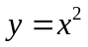
When 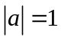, the parabola is the SAME WIDTH as
When 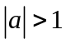, the parabola is a SHRINK AND SKINNER than
- Axis of symmetry: This is a vertical line passing through the vertex. Its equation is: 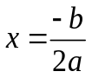

- Vertex: The highest or lowest point of the parabola is called the vertex, which is on the axis of symmetry. To find the vertex, plug in and solve for y. This yields a point (X,Y)
- X-intercepts: are the 0, 1, or 2 points where the parabola crosses the x-axis.
Plug in y = 0 and solve for x.
- Y-intercept: is the point where the parabola crosses the y-axis.
Plug in x = 0 and solve for y.
Without graphing the quadratic functions, complete the requested information:
3.) 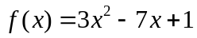  What is the direction of opening? _______  Is the vertex a max or min? _______  Fatter or thinner than y = x² ? __________  (A STRETCH OR SHRINK) | 4.) 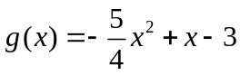  What is the direction of opening? _______  Is the vertex a max or min? _______  Wider or narrower than y = x² ? ___________  (A STRETCH OR SHRINK)
Y = X² → | THE PARENT GRAPH

The parabola y = x² is graphed to the right.  Note its vertex (0,0) and its width.  You will be asked to compare other parabolas to this graph. | 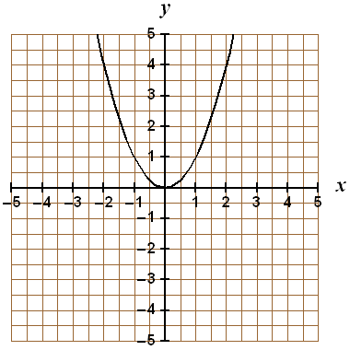

Graphing in STANDARD FORM (): we need to find the vertex 1st

Vertex  - List a = ____, b = ____, c = ____  - Find x = 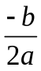  - Plug this x-value into the function (table)  - This point (___, ___) is the vertex of the parabola | Graphing  - Put the vertex you found in the center of  your x-y chart.  - Choose 2 x-values less than and 2 x-values more than your vertex.  - Plug in these x values to get 4 more points.  - Graph all 5 points  OR Find the Y-INTERCEPT AND REFLECT OVER THE AXIS OF SYMMETRY

Find the vertex of each parabola. Graph the function and find the requested information for numbers 5-8.

5) f(x) = 2x² – 3 a = ____, b = ____, c = ____
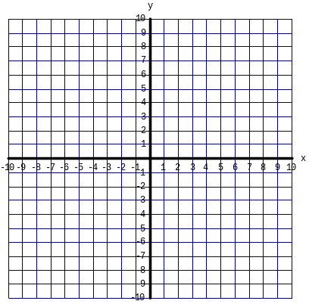  HINT : THERE IS NO MIDDLE TERM | Direction of opening? _______  Axis of symmetry: ________  Vertex: _______  Max or min? _______  Y intercept ________  Reflect y Intercept________  Compare to the graph of y = x²  _________________________

YOU CAN ALWAYS MAKE A TABLE OF VALUES TO GRAPH!!!!!

6.) f(x)= x² + 2x + 3 a = ____, b = ____, c = ____ | Direction of opening? _______  Axis of symmetry: ________  Vertex: _______  Max or min? _______  Y intercept ________  Reflect y Intercept________  Compare to the graph of y = x²  _________________________

7.) h(x) = 2x² + 8x + 1 a = ____, b = ____, c = ____ | Direction of opening? _______  Axis of symmetry: ________  Vertex: _______  Max or min? _______  Y intercept ________  Reflect y Intercept________  Compare to the graph of y = x²

8.) G(x) = -3x² + 6x + 1 a = ____, b = ____, c = ____

GRAPH OF INTERCEPT FORM y = a(x − p)(x − q):

Characteristics of the graph y = a(x − p)(x − q):
- The x-intercepts are ___ and ___.

- The axis of symmetry is halfway between (___, 0) and ( ___ , 0) the roots and can be found by adding the roots and dividing by 2.

- The graph opens up if a > 0 and opens down if a < 0.

9.) Graph y = −2(x − 1)(x − 5) | x-intercepts: _______, _______  Vertex: _______
Converting between forms:
From intercept form to standard form  - Use FOIL to multiply the binomials together  - Distribute the coefficient to all 3 terms | Ex: 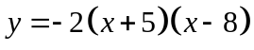
From vertex form to standard form  - Re-write the squared term as the product of two binomials  - Use FOIL to multiply the binomials together  - Distribute the coefficient to all 3 terms  - Add constant at the end | Ex: 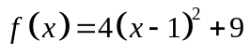

Solving quadratics by Factoring

A. Factoring Quadratics
Examples of monomials:_______________________________
Examples of binomials:________________________________
Examples of trinomials:________________________________

Strategies to use: (1) Look for a GCF to factor out of all terms
(2) Look for special factoring patterns as listed below
(3) Check your factoring by using multiplication/FOIL
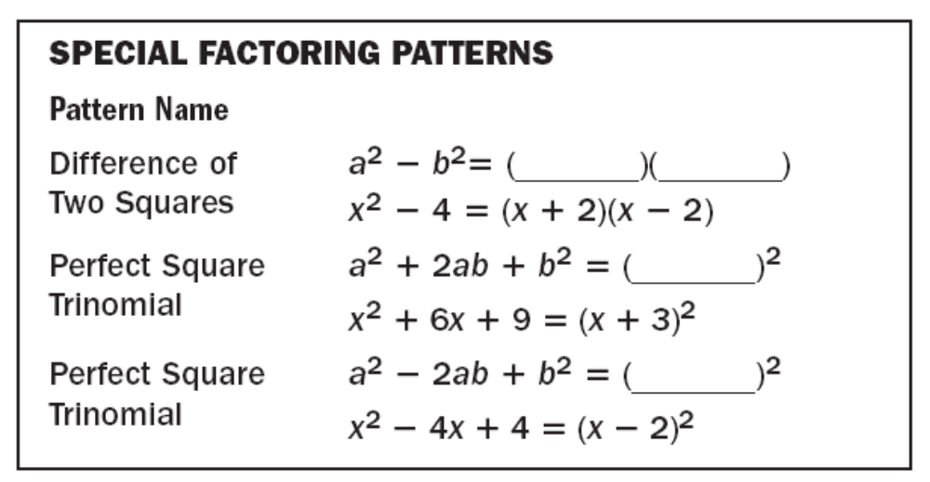
Factor each expression completely. Check using multiplication.
1.) 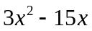 | 2.) 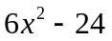 | 3.) 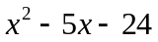
4.) 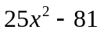 | 5.) 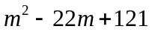 | 6.) 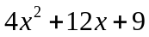

7.) 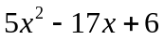 | 8.) 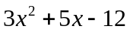 | 9.) 25t² − 110t + 121
10.) 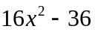 | 11.) 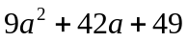 | 12.) 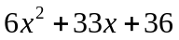

FINDING THE SOLUTIONS TO QUADRATIC EQUATIONS BY FACTORING

To solve a quadratic equation is to find the x values for which the function is equal to ZERO (0). The solutions are called the roots, intercepts, zeros, or solutions of the equation. To do this, we use the Zero Product Property:

ZERO PRODUCT PROPERTY
 | If the _________ of two expressions is zero, then _______ or _______ of the expressions equals zero.
Algebra | If A and B are expressions and AB = ZERO , then A = 0 or B = 0.
Example | If (x + 5)(x + 2) = 0, then x + 5 = 0 or x + 2 = 0. That is,  x = -5 or x =-2

Use this pattern to solve for the variable:
  - get the quadratic = 0 and factor completely
  - set each ( ) = 0 (this means to write two new equations)
  - solve for the variable (you sometimes get more than 1 solution)

FIND THE ROOTS OF EACH EQUATION by FACTORING AND USING ZERO PRODUCT PROPERTY (SET EQUATION EQUAL TO 0)
13.) 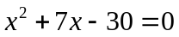 | 14.) 4x² + 8x + 3 | 15.) 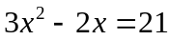
16.) 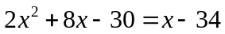 | 17.) v(v + 3) = 10 | 18.) 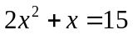

19.) 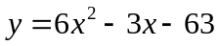 | 20.) 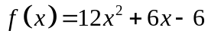 | 21.) 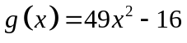

Graph the function. Label the vertex and axis of symmetry:
22.) f(x) = 4x² + 8x + 3 | Roots________  Vertex: _______  Maximum or minimum value: _______  x-intercepts: _______  Axis of symmetry: ________  Compare width to the graph of y = x²  _________________________

Solving Quadratic Equations Using QUADRATIC FORMULA

SING THE SONG!

Solving Quadratics using the Quadratic Formula

Solving using the quadratic formula:
- Put into standard form (ax² + bx + c = 0)
- List a = , b = , c =
- Plug a, b, and c into 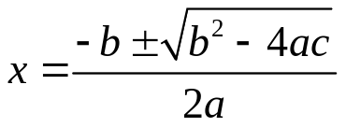
Solve by using the quadratic formula:
1.) f(x) = x² + x - 12
Must be in standard form

a = _____
b = _____
c = _____
2.) 5x² – 8x + 3
Must be in standard form

a = _____
b = _____
c = _____

3.) -x² + x = -1 4.) 3x² = 7 – 2x

5.) -x² + 4x = 5 6.) 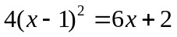

YOUR TEXTBOOK PAGE:

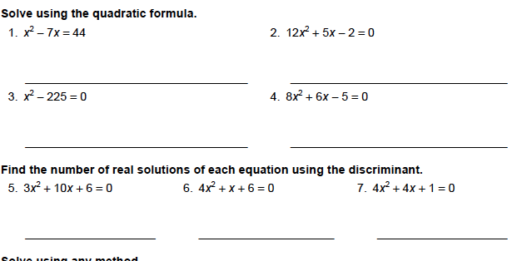
SOLVE
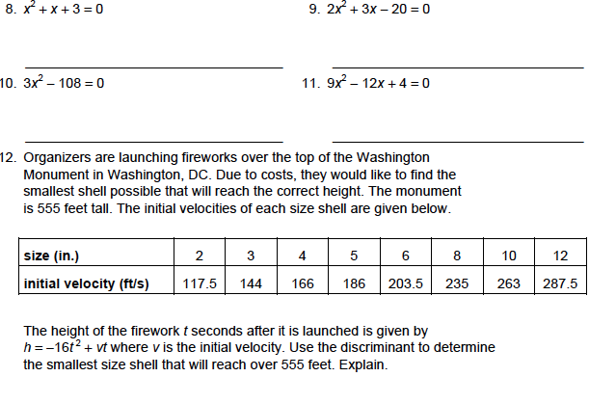
Using the Discriminant
- Quadratic equations can have two, one, or no solutions (x-intercepts). You can determine how many solutions a quadratic equation has before you solve it by using the ________________.
- The discriminant is the expression under the radical in the quadratic formula: 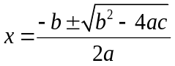
Discriminant = b² – 4ac
If b² – 4ac < 0, then the equation has 2 imaginary solutions
If b² – 4ac = 0, then the equation has 1 real solution
If b² – 4ac > 0, then the equation has 2 real solutions

Find the NUMBER of x-intercepts,
(Determine whether the graphs intersect the x-axis in zero, one, or two points).

1.) 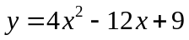 2.) 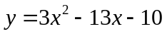

3.) y =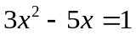 4.) 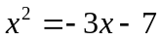

5.) 9x² – 6x = 1 6.) 4x² = 5x + 3

VERTEX FORM

Another useful form of the quadratic function is the vertex form: y = a(x − h)² + k

GRAPH OF VERTEX FORM y = a(x − h)² + k
- The vertex is (h, k).
- The axis of symmetry is x = h.
- The graph opens up if a > 0 and down if a < 0.

What is the vertex of the quadratic: g(x) = 2(x-2)² + 2

9.) Write a quadratic function in vertex form for y = −3x² + 12x − 6

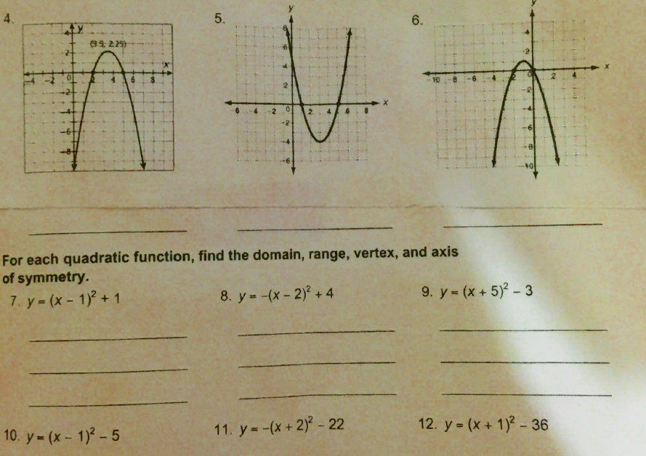
Solve Quadratic Equations by Finding Square Roots

Simplifying Square Roots:
- Make a factor tree; circle pairs of “buddies.”
- One of each pair comes out of the root, the non-paired numbers stay in the root.
- Multiply the terms on the outside together; multiply the terms on the inside together
Simplify:
1.) 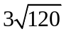 | 2.) 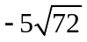
Solving Quadratic Equations Using Square Roots
- Isolate the variable or expression being squared (get it ______________)
- Square root both sides of the equation (include + and – on the right side!)
- Solve for the variable (make sure there are no roots in the denominator)

1.) x² = 25 2.) 3x² = 81

3.) 4x² – 1 = 0 4.) 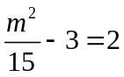

5.) (2y + 3)² = 49 6.) 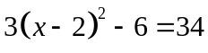

Solving Quadratic Equations Using Completing the Square

Completing the Square 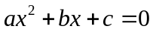
- Take half the b (the x coefficient)
- Square this number (no decimals – leave as a fraction!)
- Add this number to the expression
- Factor – it should be a binomial, squared ( )²

4.) x² + 6x + _____ 5.) m² – 14m + _______
( )( )

( )²

Find the value of c such that each expression is a perfect square trinomial. Then write the expression as the square of a binomial.
6.) w² + 7w + c 7.) k² – 5k + c

8.) x² + 4x – 5 = 0 9.) m² – 5m + 11 = 10

10.) 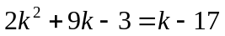 11.) 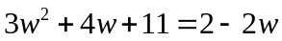

SECTION 8-7 in your textbook

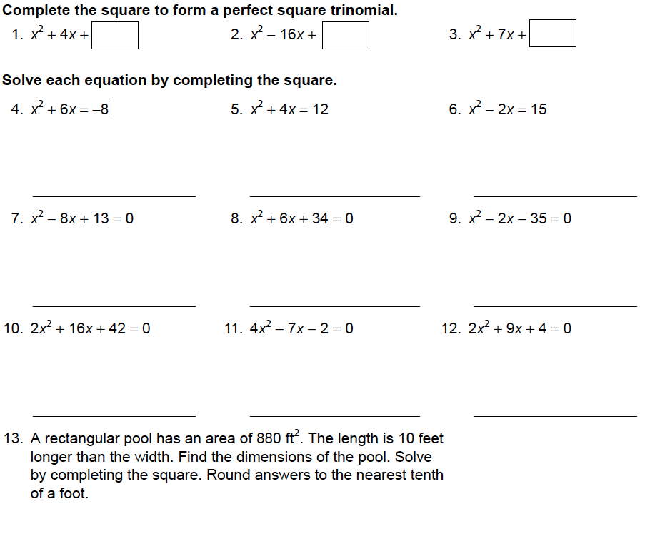

12.) 2x² – 3x – 1 = 0 13.) 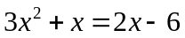

SUMMARY OF FORMS OF QUADRATIC FUNCTIONS

To graph a quadratic function, you must FIRST find the vertex (h, k)!!

(A) If the function starts in standard form 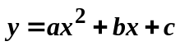:
1st: The x-coordinate of the vertex, h, = 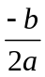
2nd: Find the y-coordinate of the vertex, k, by plugging the x-coordinate into the function & solving for y.

(B) If the function starts in intercept form 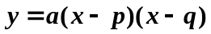:
1st: Find the x-intercepts by setting the factors with x equal to 0 & solving for x.
2nd: The x-coordinate of the vertex is half way between the x-intercepts.
3rd: Find the y-coordinate of the vertex, k, by plugging the x-coordinate into the function &
solving for y.

(C) If the function starts in vertex form 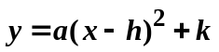:
1st: pick out the x-coordinate of the vertex, h. REMEMBER: h will have the OPPOSITE sign
as what is in the parenthesis!!
2nd: Pick out the y-coordinate of the vertex, k. It will have the SAME sign as the what is in the
equation!

AFTER finding the vertex:
Find the y-intercept and reflect over the axis of symmetry or

Make a table of values with 2 additional points:

Direction of Opening:
If a is positive, the graph opens up
If a is negative, the graph opens down.

Width of the function:
If , the graph is narrower than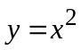
If , the graph is wider than

SUMMARY Methods for Solving Quadratic Equations:

A.) Factoring
1st: Set equal to 0
2nd: Factor out the GCF
3rd: Complete the X & box method to find the factors
4th: Set every factor that contains an x in it, equal to 0 & solve for x.

B.) Quadratic Formula
1st: Set the equation equal to 0.
2nd: Find the values of a, b, and c & plug them into the Quadratic Formula:
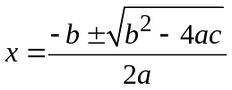
3rd: Simplify the radical as much as possible.
4th: If possible, simplify the numerator into integers.
5th: Divide. REMINDER: If you have 2 terms in the numerator (ex: 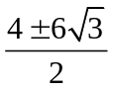), divide BOTH
terms by the number in the denominator (the example would result in 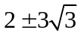)

C.) Finding Square Roots
1st: Isolate the term with the square.
2nd: Take the square root of both sides of the equation. REMINDER: Don’t forget the
3rd: Solve for x.

D.) Completing the Square
1st: Move the constant (number with no variable) to the right so that all variables are on the left
& all constants are on the right.
2nd: Divide every term in the equation by the value of a, if it is not already 1.
3rd: Create a perfect square trinomial on the left side by adding 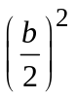 to both sides.
4th: Factor the left side into a 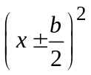 and simplify the value on the right side.
5th: Take the square root of both sides of the equation. REMINDER: Don’t forget the
6th: Solve for x

IN A NUT SHELL
By Factoring:
4.) x² – 4x – 5 = 0 | 5.) 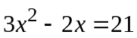 | 6.) 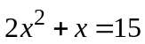
By Quadratic Formula:
10.) x² + x = 12 | 11.) 5x² – 8x = -3 | 12.) 2x² = 4 – 7x
By Square Roots:
1.) (2y + 3) ² = 49 | 2.) (3m – 1) ² = 20 | 3.) 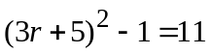
By Completing the Square:
7.) x² – 6x – 11 = 0 | 8.) 2y² + 6y – 18 = 0 | 9.) 2x² – 3x – 1 = 0

