1.4 NOTES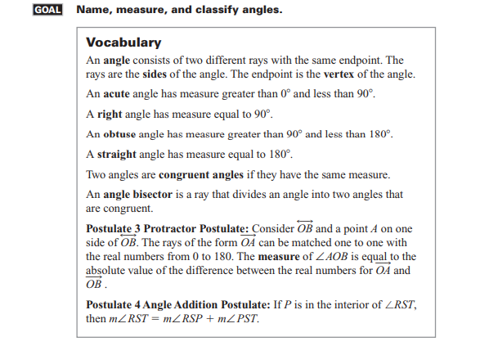

Example 1
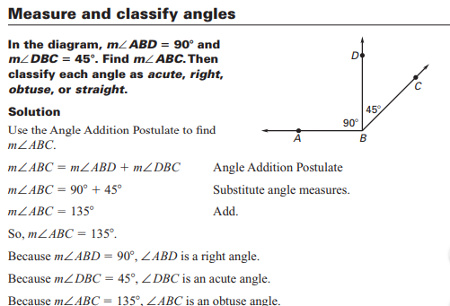

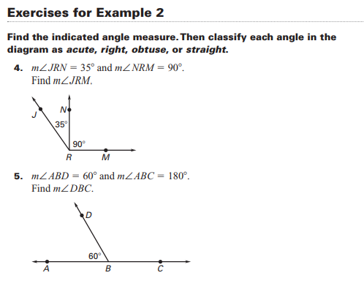
Solutions
4. 125 degrees; ∠JRN is acute; ∠NRM is right; ∠JRM is obtuse.
5. 120 degrees; ∠ABD is acute; ∠DBC is obtuse; ∠ABC is straight.

