Chapter 1 Review Answers – Must show work for credit, no work, no credit
- Endpoints
- 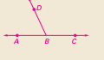 an example
- Midpoint
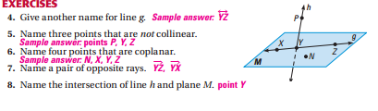
9. 1.2
10. 30
11. 7
12. no, because DE =24 and GH = 5
13. 16
14. 2.8, mp=(7,11)
15. 8.6, mp=(3.5, 3.5)
16. 9.4, mp=(1,6.5)
17. 16.4, mp=(5, -.5)
18, (7,11)
19. 5
20 50 degrees
21. 162 degrees, obtuse
22. 78 degrees
23. 7 degrees
24. 44 degrees
25. 88 degrees
26. 64 degrees
27. 124 degrees
28. 91 degrees
29. 168 degrees
30. 10 degrees, 80 degrees
31. 92 degrees, 88 degrees, obtuse
32. Triangle, regular, 3 congruent sides and 3 congruent angles
33. Quadrilateral, equiangular, only 4 congruent angles
34. Octagon, equilateral – eight congruent sides –evident by tic marks,

Make sure you can find the endpoint given a midpoint and one endpoint. Do the chapter test in textbook for an additional 5 points. Study and come prepared.

